Ideation Phase

Define the Problem Statements

Date | 15 Feb 2026
Team ID | LTVIP2026TMIDS44629
Project Name | Measuring the Pulse of Prosperity: An Index of Economic Freedom Analysis
Maximum Marks | 2 Marks

Customer Problem Statement :
Policy makers, economists, researchers, and business strategists face significant challenges in understanding how economic freedom influences prosperity, investment growth, entrepreneurship, and quality of life across countries and regions. Economic data is often scattered across multiple global databases and presented in raw statistical formats, making it difficult to interpret trends in regulatory efficiency, government size, trade openness, property rights protection, and market competitiveness.
Without effective visual analytics tools, analyzing relationships between economic freedom indicators and national prosperity becomes time-consuming and heavily dependent on manual reports. This lack of clear, centralized insight prevents decision-makers from identifying policy gaps, benchmarking national performance, and designing reforms that encourage economic growth and business development.
There is a critical need to compare economic freedom scores across different time periods (for example, year-wise trends) and across countries or regions to understand how policy changes, regulatory reforms, and governance quality influence economic performance and societal well-being.
By developing an interactive visual analytics solution (using tools like Tableau or Power BI), stakeholders can:
- Track economic freedom scores by country and indicator
- Compare performance across regions and income groups
- Analyze time-based trends and reform impacts
- Identify strengths and weaknesses in policy frameworks
- Examine relationships between economic freedom and prosperity indicators (GDP growth, investment, employment)
- Detect opportunities for policy improvement and economic reform
This interactive data storytelling approach transforms complex economic datasets into actionable policy intelligence, enabling strategic decisions that support sustainable growth, investment confidence, and national prosperity.

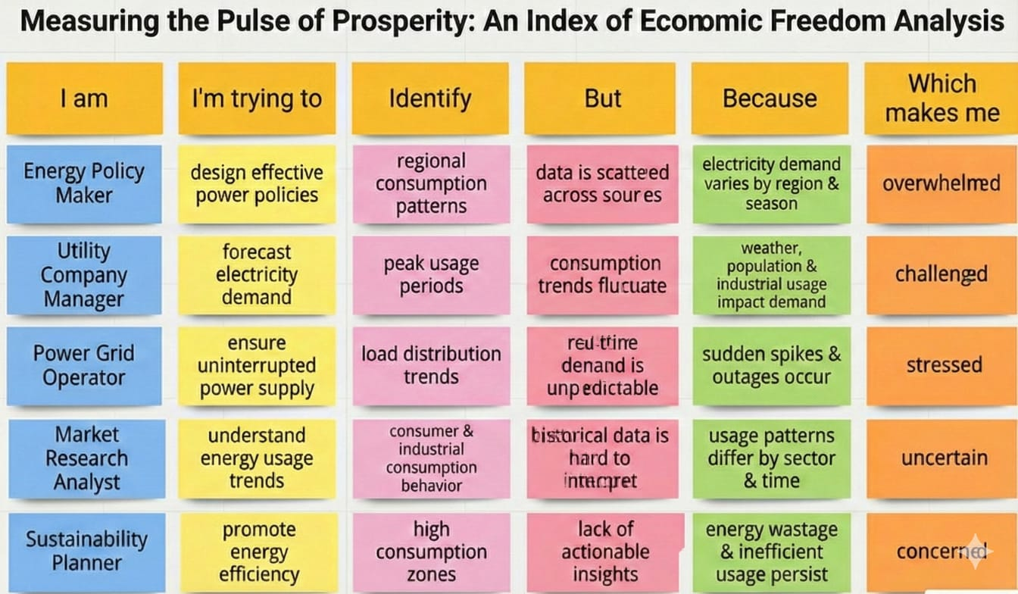
concerned

PS ID | I am | I’m trying to | But | Because | Which makes me feel
PS-1 | a policy maker | evaluate my country’s economic freedom performance | data is scattered across multiple global reports | there is no centralized analytics dashboard | uncertain about policy priorities
PS-2 | an economist/researcher | compare economic freedom trends across countries and years | I cannot easily visualize indicator trends | datasets are complex and fragmented | frustrated and time-constrained
PS-3 | a government advisor | present economic reform insights to leadership | reports lack visual clarity and compelling storytelling | dashboards are static and non-interactive | ineffective during policy discussions
PS-4 | a business strategist | assess investment climate and market openness | I cannot correlate freedom indicators with economic growth | existing tools lack deep analytical capability | unable to recommend data-driven investment strategies

